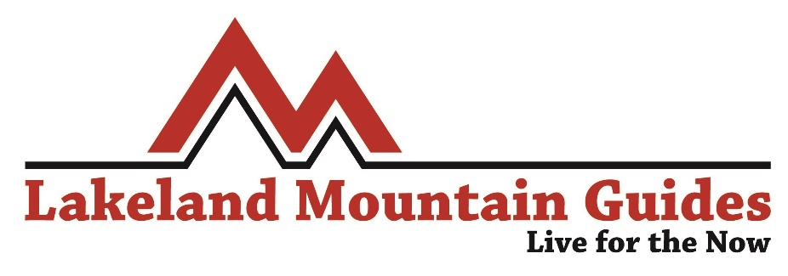
TRAINEE LEADER DEVELOPMENT SCHEME APPLICATION FORM 2020
The TLDS is best suited to those who are committed to obtaining their Mountain Leader award in 2020, preferably towards the autumn so you get a full season out of the scheme before you qualify. Supervision opportunities fall throughout the week and weekends. The scheme generally runs between April and October and you will join us for one season.
Throughout the year we will run some subsidised workshops focussing on key areas of the mountain leader syllabus such as navigation (day and night) and security on steep group. These workshops cost in the region of £30 to attend. At the end of the year, should there be demand from the candidates, we will also run a 3 day / 2night ‘mock expedition’ which always serves as a great primer before assessment. This costs £125 to attend.
We have opportunities in the Lake District and Snowdonia and so being able to travel to one or both of these regularly is favourable. There are some opportunities in Scotland throughout the year too. For 2020 we will only be taking on half a dozen trainees and so only the most committed and suitable will end up on the scheme, so please take the time to complete the application form to the best of your ability in order to give yourself the best opportunity to join us in 2020.
Name
Contact Number
Where do you currently live?
When did you complete your ML training?
Why are you aiming to be an ML award holder?

Why do you feel you will suit the scheme?
Do you hold any other instructional qualifications?
Ideally, when do you hope to take your ML assessment?
Tell us a little about yourself
What is the main element of the scheme that appeals to you the most?
Have you ever undertaken any first aid training?
How did you hear about the scheme?
Other info you feel we should know (General availability, work commitments etc)

Once you have completed the form, please email it to lakelandmountainguides@live.co.uk along with a copy of your ML Training Certificate, BMC Member Card and First Aid Certificate if applicable.
Thank you for your application, we will be in touch as soon as possible.

